Clawson Care 365

Contents

Key areas of the Standard ..1
Mission Statement 2
1.0 General Farm Standards 3
2.0 Livestock Health Plans, Animal Welfare, Mobility & Cow Condition Scoring 4-5
3.0 Antibiotic Usage & Control 6
4.0 Disease Control and Eradicaton (Johne’s & BVD) 7
5.0 Milk Quality 8
6.0 Information Portal …………………………………………………………………………………… 9
7.0 Auditing of the Standard 9
Appendix 1 – Clawson Farm Care Team 10
Appendix 2 – Antibiotic Failure Investigation Forms…………………………………….. 11

Mission Statement
Clawson’s strategy is to ensure that all its milk suppliers exceed a set of standards that covers animal welfare, farm and milk quality, thus enabling Clawson to meet the expectations of our global customers and consumers 365 days a year
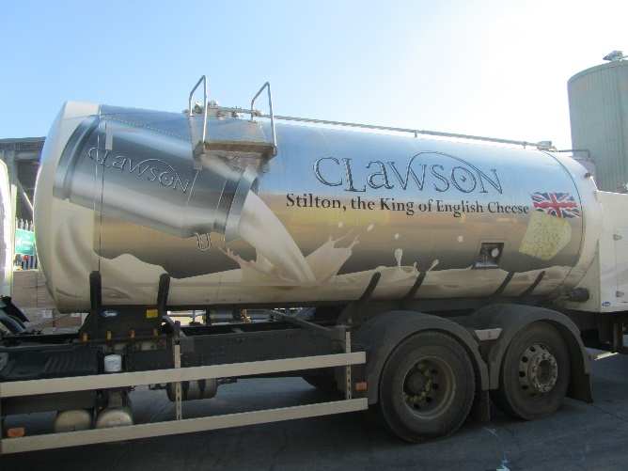
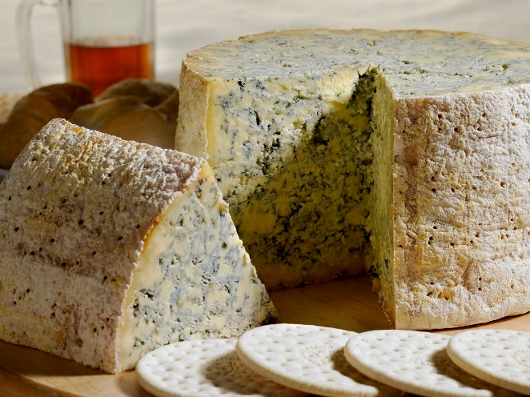

Clawson will review the Standard every year to ensure it remains robust and relevant to exceed the expectations of our global customers and consumers

The Clawson Standard is additional and supplementary to any UK/EU regulatory requirements and Red Tractor Assurance (Dairy Standard)

Audit Scoring and Ranking
C = Critical – This is a must have, that has the potential to put the farm or Clawson at significant risk of reputation damage
F = Fundamental – This is expected to be part of your day to day management on the farm

Ranking – Any the clauses that are not compliant will be scored at follows

Green 1 – 4 fundamental clauses, closed out within agreed timescales
Amber 5 – 10 fundamental clauses, closed out within agreed timescales, additional audits may be required dependent on the non-compliant clauses
Red – Greater than 10 fundamental clauses and any critical clause, actions within agreed timescales and the farm will be subject to additional audit

1.0 General Farm Standards
Objective – To ensure there is a positive public perception of all Clawson farms, that gives the confidence animal welfare is being managed to a high standard and our farms are safe places to produce food
1.1 The following must be kept clean and tidy at all times

    - (C) Milk collection areas
    - (C) Areas that can be viewed by the public, from roads, pathways, public rights of way through land
    - All waste on farm, such as old plastic, packaging, scrap metals, are to be well managed so they do not create a negative view of the farm

  - (C) Each farm to have a designated area for dead or fallen stock, away from public view. All fallen stock should be removed from the farm without undue delay

  - (C) All lame and downer cows to be managed and treated away from public view

  - (C) Milk collection areas must be free from mud and manure, so that the driver and milk collection hose can move freely between the tanker and milk storage tank on hard standing, to reduce the risk of spreading disease from farm to farm

  - (C) The dairy, milk tank/silo must be kept secure at night and when it is unattended

  - (F) All suppliers must ensure there is a copy of the Clawson Farm and Red Tractor Standards available to all farm staff

  - (C) All suppliers must ensure a copy of the farm and Clawson emergency contact numbers and plans, are displayed in a position that is accessible to all farm staff

  - (F) Vermin control must be in place in areas where feed is stored, animals housed, milking parlour and milk tank / silos, in line with current legislation, and managed by a competent person or external contractor

1.9 (F) If the bore hole water is used on farm it must be tested twice a year for
TVC, Coliforms and pseudomonas

2.0 Livestock Health Plans, Animal Welfare & Mobility and Cow Condition Scoring

2.1 Livestock Health Plans
Objective – Every farm must have an active up to date Livestock Health Plan
    - (C) Each farm must have a Livestock Health Plan that is established in conjunction with their vet and carried out at least once a year with their vet
    - (C) All Livestock Health Plans must cover the following areas: -
    - Animal welfare, lameness, mastitis, mortality, culling
    - Management of calves
    - Control and usage of veterinary medical products
    - Disease control and eradication, which must include Johne’s and BVD

To ensure the farm can meet all the requirements of the Clawson Standard

2.2 Animal Welfare
Objective – Ensure all farms operate to high animal welfare standards to exceed our global customers & consumers expectations
    - (C) Calves are not euthanased on farm, unless welfare issues justify this taking place – e.g. TB restrictions

    - (F) Farmers and vets include in the Livestock Health Plan a strategy to reduce downer cows e.g. milk fever control and floor surfaces

    - (F) All milk suppliers must have a proactive approach to improve animal welfare on their farms

    - (F) All farm staff must be competent to carry out their tasks and be able to demonstrate they have the necessary experience and / or training to carry out their duties, in relation to livestock management

    - (F) Records must be kept for all farm staff that shows their induction to the farm, experience, qualifications and training, this information must be available for inspection

2.3 Mobility and Cow Condition Scoring

Objective – Improve overall herd health
    - (C) Whole herd to be scored every six months using the method and standards set out by the AHDB*, by a trained member of farm staff

    - (C) Target a year on year improvement in herd health by reducing the number and severity of poor condition cows: -

  - From April 2019 – All farms are to score to a common standard set out by the AHDB for mobility and condition scoring

  - From April 2020 – A precise scoring system will be introduced with targeted reductions

*Alternative methods of scoring are acceptable as long as the farm can demonstrate it can achieve the same standard as the AHDB system

3.0 Antibiotic Usage and Control
Objective – Control the use of all veterinary medical products on farm to a high standard
  - (F) Farms have sufficient individual cow information to ensure all treatment is focused on the need of the cow that requires treatment, and this is in line with objectives set out in the Livestock Health Plan

  - (C) Livestock are only treated with approved and registered veterinary products for dairy cattle. Prescribed withdrawal periods must be strictly observed at all times, if any antibiotics are used off label, the farmer must follow the advice of their vet

  - (C) From the 31st January 2019 all farm staff associated with livestock that are required to handle or administer veterinary medical products must be MilkSure trained, and hold an up to date Certificate of Competence

  - (C) Any new staff joining the farm after January 2019, that are required to handle or administer veterinary medical products, must be qualified within four months of their starting date

  - (C) Each farm has a control procedure for storage, usage and recording of antibiotics and veterinary medical products

  - (C) From January 2019 Critically Important Antibiotics (CIA) are only to be used if sanctioned by a vet (the aim is to phase out their use)
If any Critically Important Antibiotics (CIA) are kept on farm, they should be stored in a separate locked box in the medicine cabinet clearly marked:-
“Use must be sanctioned by the farm vet”

Clawson supports the voluntary restriction on the use of Colistin in farm animals

  - (C) Waste antibiotic milk is not used for feeding young dairy stock, unless there is an overriding welfare reason e.g. colostrum

  - (F) Following any antibiotic failure, the farm must identify the root cause of the incident and put corrective actions in place to prevent the same thing recurring. Appendix 2 Antibiotic Failure Investigation Form

  - (F) Any other farm animals (non- Bovine) that receive any treatment must also be captured

Clawson actively encourages farms to reduce the use of antibiotics by, not using antibiotics in foot baths, blanket treating of calves and considering Selective Dry Cow Therapy (SDCT)

4.0 Disease Control and Eradication (Johne’s & BVD)

4.1 Johne’s Disease Control
Objective – Reduce disease prevalence of Johne’s in the herd, so there are fewer infected cows year on year
    - (C) Whole herd to be tested at least once a year, the results to be reviewed with the farm vet to establish a farm control plan to reduce incidents of Johne’s on all farms to a low level: -

      - (C) The Johne’s plan must consider the management of clinical (red) cows and their bio containment of these cows
      - (C) The general bio security of the farm to ensure the segregation of high clinical and low clinical cows
      - (C) Milk and colostrum from infected cows is not fed to replacement heifer calves

    - (C) Farms to use vets that are competent in Johne’s assessment and control plans.

    - (C) From April 2019 must complete and return NJMP Vet Declaration to Clawson.

4.2 BVD Disease Control and Eradication
Objective – Reduce the incidents of and work towards the eradication of BVD
    - Every bulk tank is tested twice a year – Clawson will co-ordinate this via NML

    - (F) Test results are used as part of the Livestock Health Plan with the objective of eliminating BVD by adopting appropriate biosecurity measures

    - (F) Farms are encouraged to participate in the national BVD funded schemes

5.0 Milk Quality
Objective – Improve the quality of the raw milk from farm
  - (C) All farms to have a cooling system that ensures the milk is below 5°C within 30 minutes of end of milking

  - (C) Farms will be asked for a corrective action if their geometric mean goes above:-

    - BSC is greater than 80,000 (based on 2-month average)
    - SCC is greater than 350,000 (based on 3-month average)
    - If the milk goes above the targets the farm will be required to carry out a bactoscan breakdown

  - (F) If for any reason you believe the milk in the tank may have been compromised and should not be collected until further checks have taken place, the following actions must be taken:-

    - Hang a red ‘Stop do not collect’ sign from the milk tank outlet
    - Inform Clawson immediately, call numbers in Appendix 1

  - (F) Ensure there is hand washing facilities with hot water, soap, paper towels and sanitiser, available for the tanker driver and farm, near the milk storage tank
  - (F) Hygiene schedule for pipework must be in place e.g. descaling and wash temp checks

  - (C) No persons to be eating or drinking within the parlour or milk tank area (NO NUTS)

  - (F) Milk filters to be fitted to milk tank inlet, inspected, cleaned or changed as required

  - (F) Milk tanks to be appropriately hygienically designed to allow safe access and unload

  - (F) Milk tanks must be able to be isolated even when starting to off load onto tanker

  - (F) Milk tanks to be housed in a clean area that is secure from the elements and possible trespassers

  - (F) Temperature gauges on tanks to be checked a minimum of once a week

  - (F) Ensure there is a hose pipe near the milk storage tank, so the tanker driver can leave the area free from any milk residues

  - (F) New milk tanks – Before any new milk storage tanks are purchased, the farmer should agree its specification with the dairy:-

    - (F) All new storage tanks are to be fitted with a device that has an alarm function, to alert a member of farm staff if the milk goes above the target temperature for a set period

6.0 Information Portal
Objective – Improve the transfer of information between the dairy to farm and farm to dairy
  - (F) Volume forecast sheet – will be issued on and must be returned by the dates, detailed in the table below

Issued by the end of | Returned by the last Friday of | Locked off months
April | May | July, August, September
July | August | October, November, December
October | November | January, February, March
January | February | April, May, June

6.2 (F) The entire form must be completed in full to show: -
  - The three months that require locking off and the next nine forecasted months

6.3 (F) The supplier must keep the dairy informed of any changes to the following contact details: -
  - Veterinary practice and their Johne’s testing laboratory

7.0 Audits
Objective – Audits will take place to ensure farms exceed the Clawson Farm Standard
  - Short notice (24hr) or unannounced audits will be carried out by Clawson personnel or their representatives, to check compliance to the Clawson Farm Standard

  - (F) Any non-conformances that are found will be detailed, corrective actions and timescales will be agreed between Clawson and the farmer,

  - Any non-conformances not closed out within agreed timescales will be reported to the Board of Directors

Appendix 1 - Clawson Farm Care Team

Farm Liaison Director - Main farm liaison contact
kim.kettle@clawson.co.uk
Office 01664 821317
Mobile 07710 591102

Office Manager – Management of forecasts, milk intake data, milk statement and payment queries
dave.wilford@clawson.co.uk
Office 01664 821305

Logistics Manager – Management of milk collections, transport fleet
paul.taylor@clawson.co.uk
Office 01664 821327
Mobile 07880 913642

Finance Administrator – Arrange meetings, leave a message or arrange extra tests
rachel.smith@clawson.co.uk
Office 01664 821316

Emergency and Out of Hours Contacts: -

1st contact - Milk Processing – 01664 821368
2nd contact - Paul Taylor - 07880 913642
3rd contact - Kim Kettle - 07710 591102

(normal working hours are 8.30am to 5.00pm Monday to Friday)

